ITD – ITIN Power Apps Training · Student Lab Guide
Lab 01: Create the My Team Availability App
Management Workforce Availability App — building the Canvas App shell
Estimated time | 45–60 minutes
Difficulty | Beginner — no prior Power Apps experience required
Prerequisite | Lab 00 completed (environment access confirmed)
You will build | A blank Canvas App named “My Team Availability” with 6 screens and working navigation

Lab Overview
In this lab you will create the app “shell”: a blank Canvas App, its six screens, a simple navigation menu that moves between them, and a consistent visual theme. You will not connect to data yet — that happens in Lab 02. By the end of this lab you will be able to open your app and tap between every screen.

Objectives
- Create a blank Canvas App.
- Name the app “My Team Availability.”
- Add the six required screens.
- Create a navigation header or menu.
- Apply a consistent theme and layout.
- Preview and test screen navigation.

Before You Start — Power Apps Studio Orientation
Power Apps Studio is the workspace where you build your app. It always has the same four regions. Take a moment to find each one before you begin — every later lab refers back to these names.
Region | Where it is | What it's for
Command bar / ribbon | Very top of the screen | Tabs such as Home, Insert, and View, plus the Save and Play (▶) buttons
Tree view (left pane) | Left-hand side | A list of every screen and every control on the selected screen. Click a screen name here to switch to it.
Canvas (middle) | Center of the screen | The visual design surface — what you see here is what your app looks like.
Properties pane (right) | Right-hand side | Settings for whatever control is currently selected, including its formula bar.

ℹ NOTE
Above the Tree view, look for a small set of icons (a screen/pages icon, a database icon, and a paint-bucket/insert icon). Clicking the database icon opens the Data pane — you will use that in Lab 02.

Power Apps concepts used in this lab
Concept | What it means
Canvas App | An app you design freely on a blank canvas, screen by screen (as opposed to a model-driven app).
Screen | One “page” of your app. Users move between screens — they never see two at once.
Control | Any object you place on a screen: a button, label, gallery, icon, form, etc.
Property | A setting on a control, such as its Text, Color, or OnSelect behavior.
Navigate() | The formula that moves the user to a different screen.
Back() | The formula that returns the user to the previous screen.
User() | A function that returns information about the signed-in user (used starting in Lab 03).

Part A — Create the Blank Canvas App
- Go to
https://make.powerapps.com and confirm the correct environment is shown in the top-right corner (see Lab 00, Part A).
- In the left navigation bar, click “Create.”
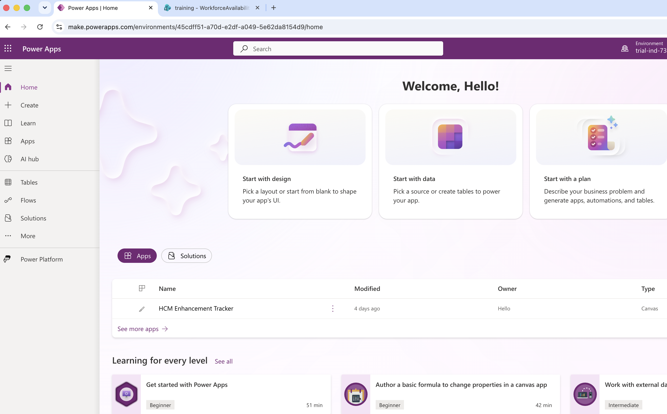
- On the Create page, find the “Start from blank” or “Blank app” section and click the “Blank canvas app” tile (it may also be labeled “Blank app” with a “Create” button beneath it).
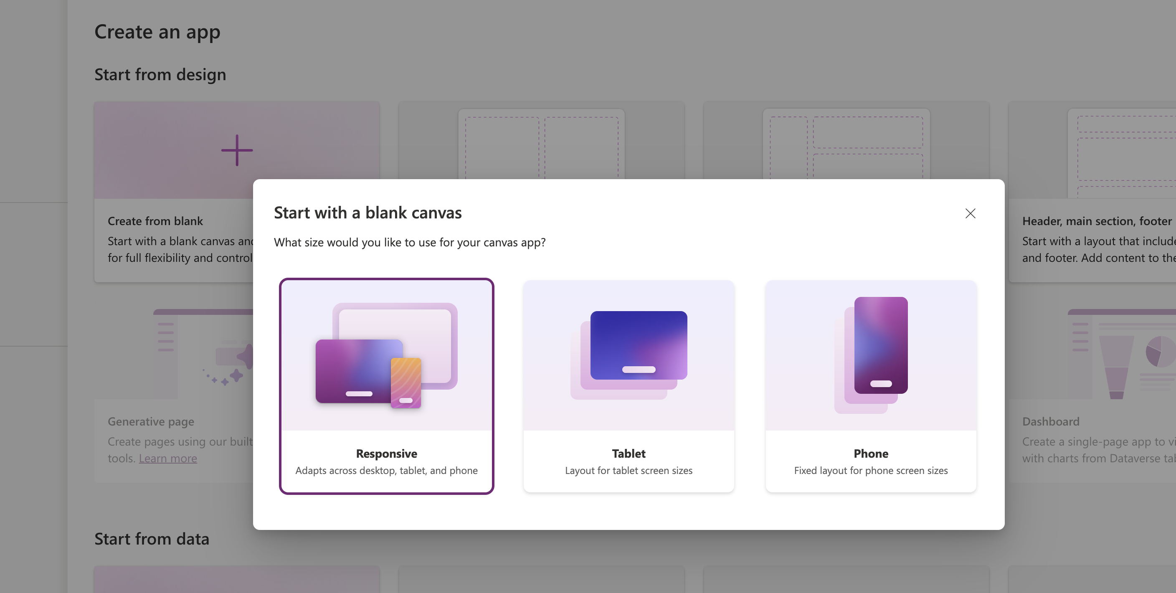
- In the dialog box that appears, fill in the two fields:
App name: My Team Availability
Format: choose Phone (this gives the tall, mobile-friendly layout the scenario calls for).
- Click “Create.” Power Apps Studio opens with one blank screen already in the Tree view, usually named “Screen1.”
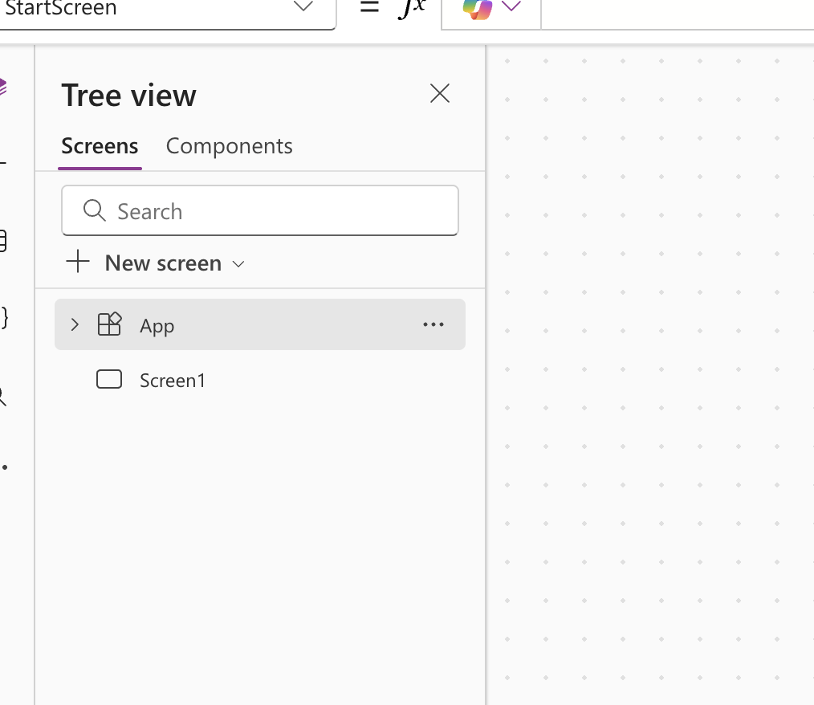
💡 TIP
The app format (Phone or Tablet) cannot be changed later without side effects, so double-check you selected Phone before clicking Create.
- Save your app immediately so you don't lose your work: press Ctrl+S, or click the Save icon (floppy disk) in the top-right of the command bar,
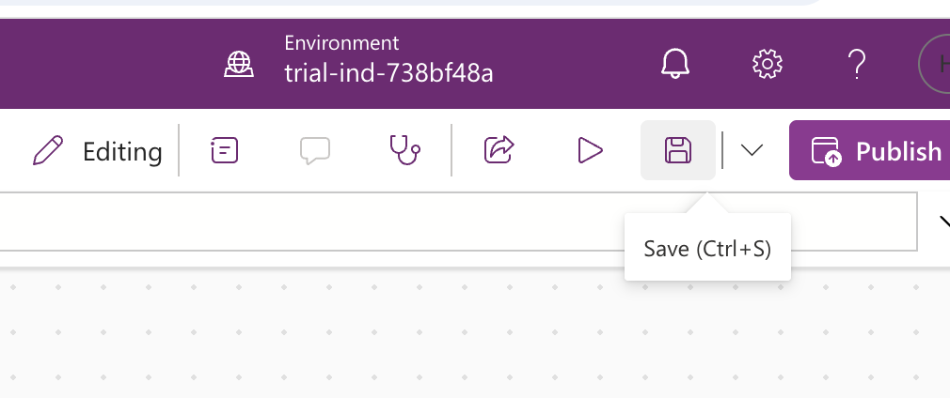
then click “Save.” If prompted for a name again, confirm “My Team Availability.”

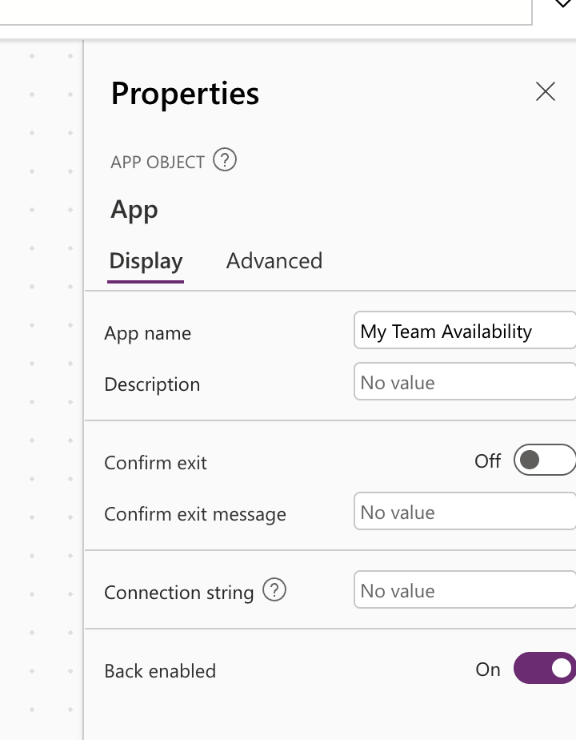
✅ CHECKPOINT
Checkpoint: You should now see Power Apps Studio open, with “My Team Availability” shown as the app name at the very top of the window, and “Screen1” listed in the Tree view on the left.

Part B — Add the Six Screens
Your app needs six screens, each with a specific purpose. You will rename the existing “Screen1” to be your Home screen, then add five more blank screens.
Screen name to use | Purpose
Home | Entry point and availability summary
My Availability | Create or update the current user's availability
My Team | Manager view of team availability
Availability Details | View a selected record
Manager Dashboard | Coverage summary and potential gaps
Help | Training guidance and field definitions

Step 1: Rename Screen1 to Home
- In the Tree view (left pane), find “Screen1”
- and right-click it.
- 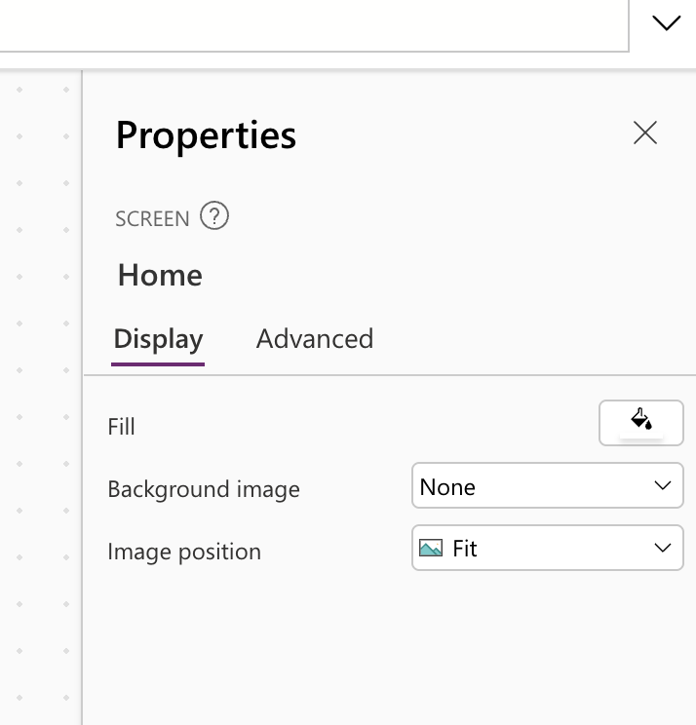
- Select “Rename” from the menu that appears (alternatively, double-click the screen name directly).
- Type
Home and press Enter.

Step 2: Add the remaining five screens
Repeat the following four steps once for each of: My Availability, My Team, Availability Details, Manager Dashboard, and Help.

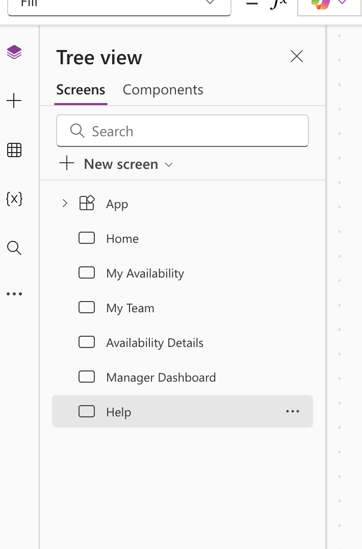
- On the command bar at the top, click “New screen.” (It may show as a button with a “+” icon, or as text “New screen” with a small dropdown arrow next to it.)
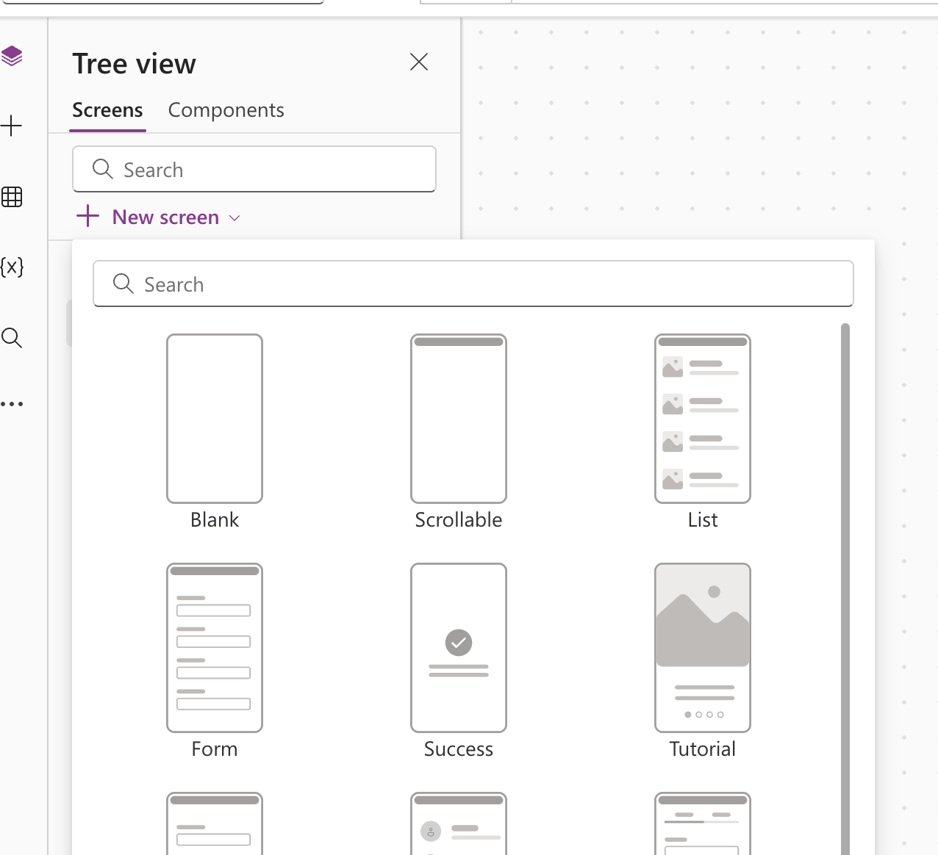
- If a dropdown of layout choices appears (Blank, List, Form, etc.), choose “Blank.” This adds a new empty screen and selects it in the Tree view.
- Right-click the new screen in the Tree view (it will be named something like “Screen2”) and choose “Rename.”
- Type the exact screen name from the table above and press Enter.
💡 TIP
Work down the list in order (My Availability, then My Team, then Availability Details, then Manager Dashboard, then Help) so the screens appear in the Tree view in a sensible order — it makes the rest of the labs easier to follow.
✅ CHECKPOINT
Checkpoint: The Tree view on the left should now list exactly six screens, in this order: Home, My Availability, My Team, Availability Details, Manager Dashboard, Help.

Part C — Build a Simple Navigation Menu
Next you will add a row of navigation buttons to the Home screen so users can reach the other screens. You will repeat this same pattern to add a “Back to Home” button on the other screens.

Step 1: Select the Home screen
- In the Tree view, click “Home.” The canvas in the middle now shows the (empty) Home screen.

Step 2: Insert a container for the menu
- On the command bar, click the “Insert” tab.
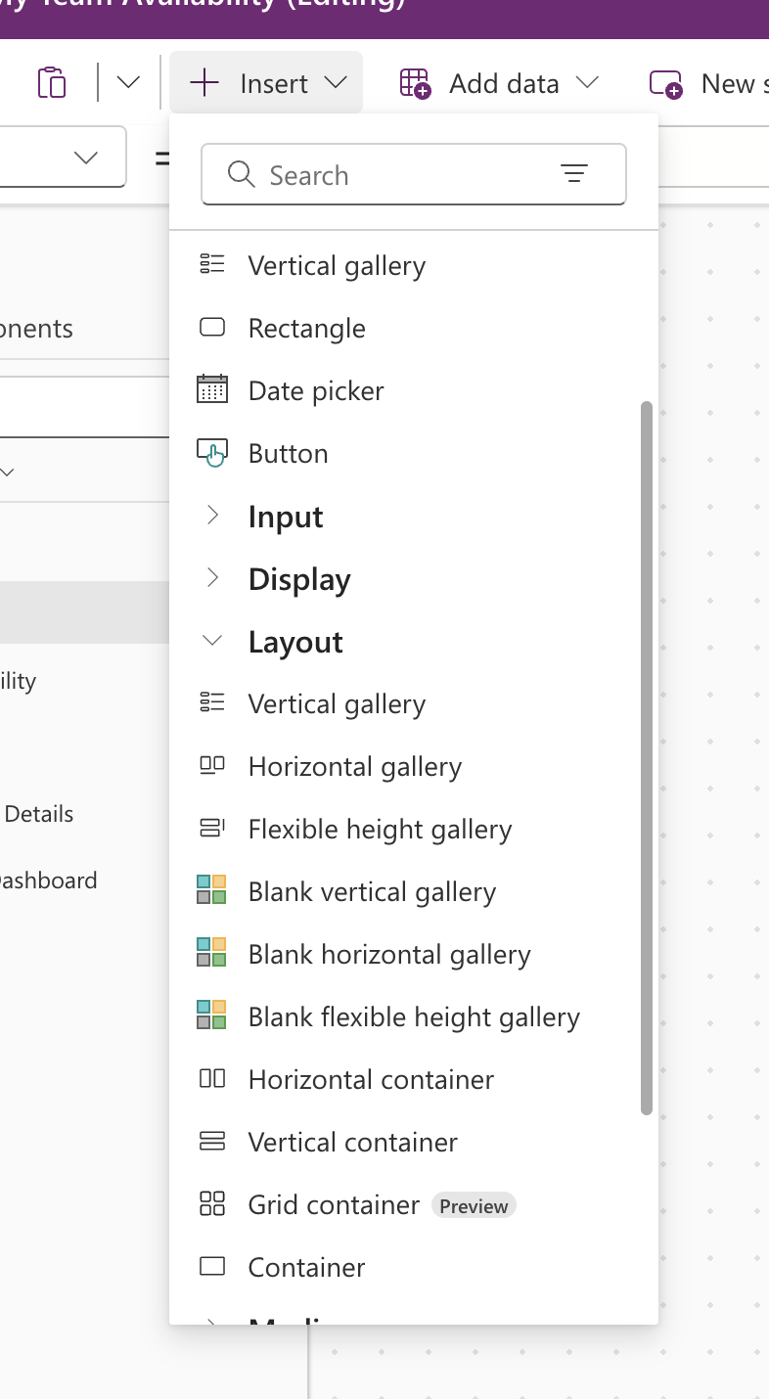
- Click “Layout” (or “Containers,” depending on your version)
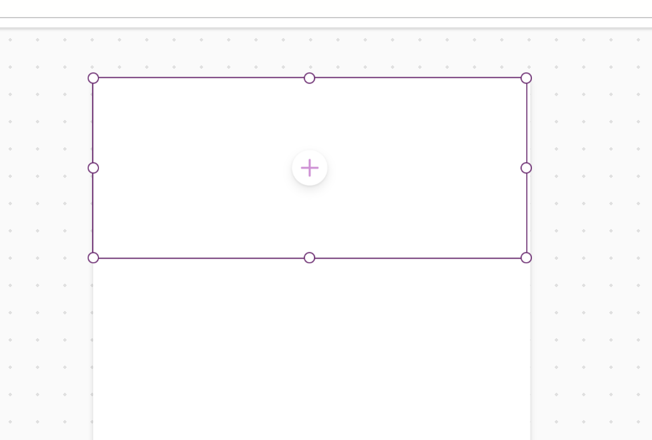
- and choose a “Horizontal container.” It will appear near the top of the canvas.
- Drag the container's edge, or use the Properties pane on the right, to position it along the top of the screen, similar to a header bar.

Step 3: Add a navigation button
- With the container selected, click the “Insert” tab again,
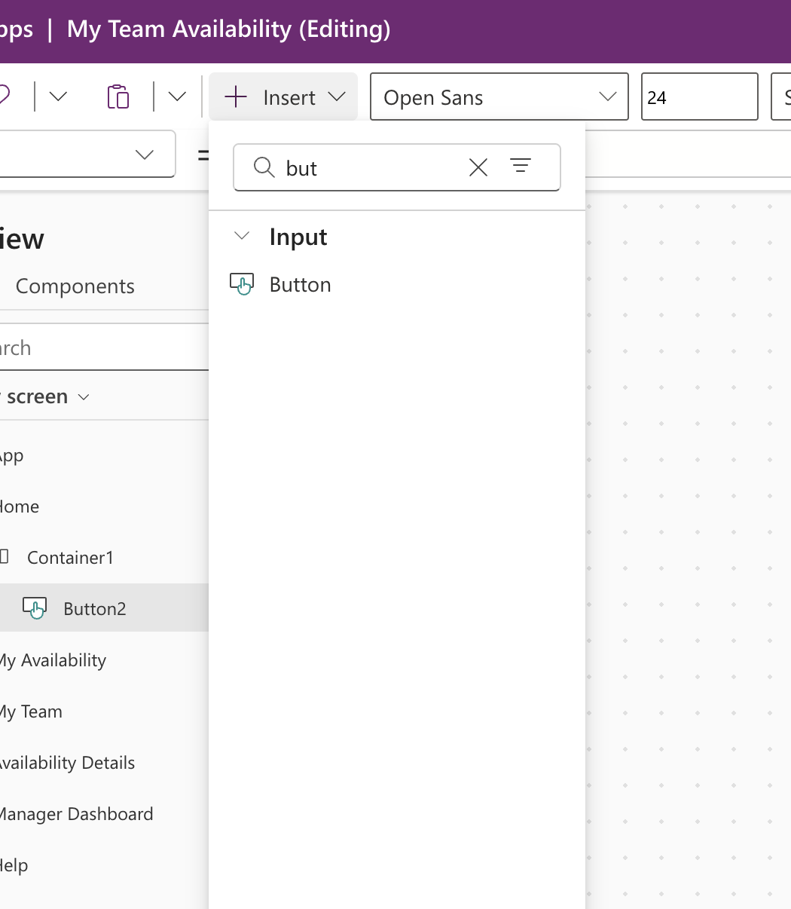
- then click “Button” under the Classic or Basic controls section. A new button appears inside the container.
- With the button selected, look at the Properties pane (right side) and find the Text property. Change it to My Availability.
- Find the formula bar just above the canvas (it starts with fx). Make sure the left-hand dropdown in the formula bar shows “OnSelect” — this is the property you are about to set.
- Click into the formula bar and type:
Navigate('My Availability',ScreenTransition.Fade)

then press Enter.
ℹ NOTE
scrMyAvailability refers to the screen you named “My Availability.” Power Apps generates an internal name like this automatically from the screen name — Power Apps will suggest it as you type Navigate(scr and you can pick it from the autocomplete list rather than typing the whole thing.

Step 4: Repeat for the remaining screens

Click rename button:

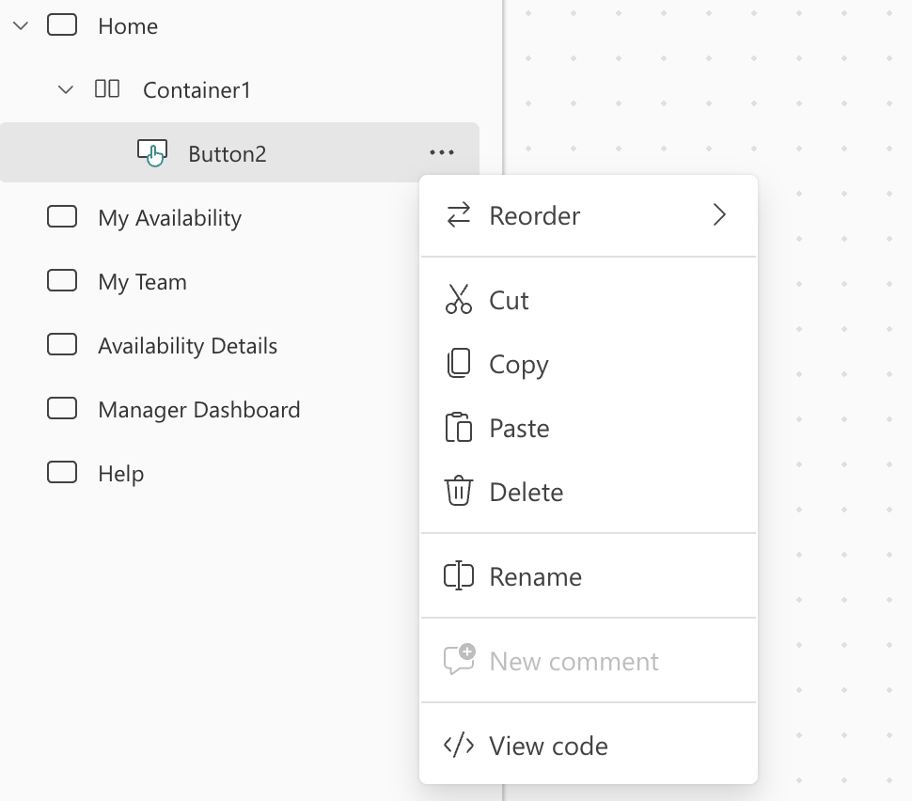

Rename the button to :

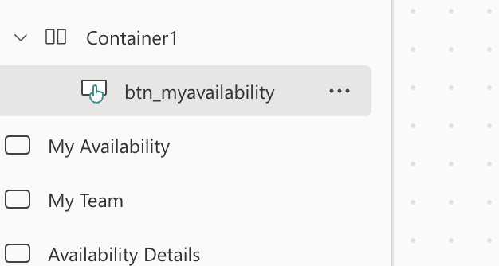
Copy and paste the button you just created (Ctrl+C, Ctrl+V) four more times
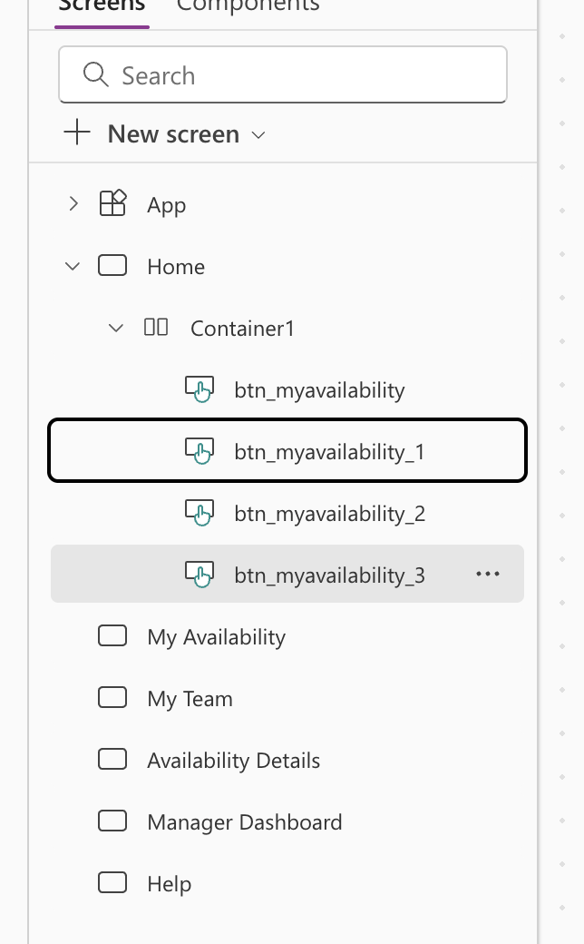
inside the same container, and for each copy, change its Text property and its OnSelect formula to match the table below.
Button text | OnSelect formula
My Team | Navigate(MyTeam, ScreenTransition.Fade)
Manager Dashboard | Navigate(ManagerDashboard, ScreenTransition.Fade)
Help | Navigate(Help, ScreenTransition.Fade)

NOTE:
1. Go to the container properties and click on vertical stack
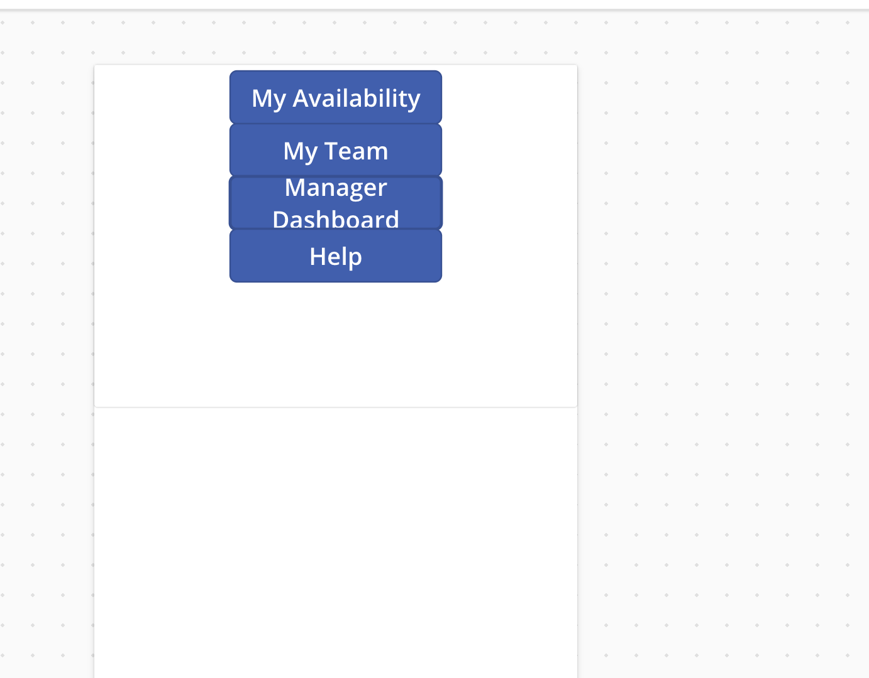

Step 5: Add a “Back” button on the other screens
Availability Details is normally reached by tapping a record rather than a menu button, so instead give it (and My Availability, My Team, Manager Dashboard, and Help) a simple way back.
- Select each screen in turn in the Tree view (for example, click “My Availability”).
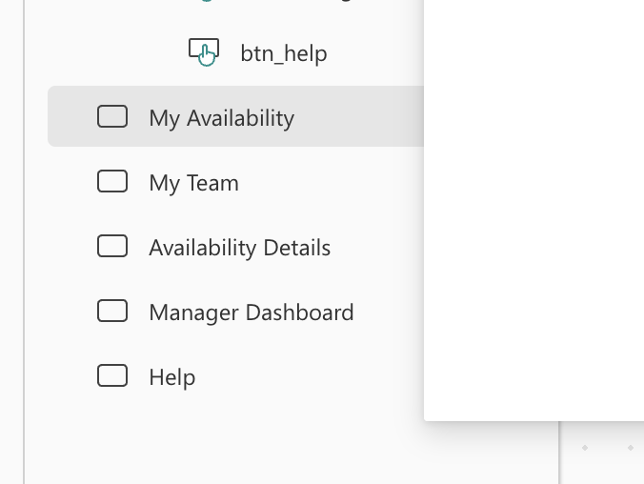
- Insert a button (Insert tab → Button) in a corner of the screen,
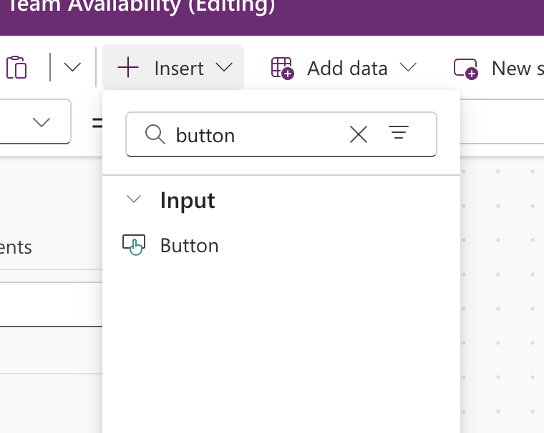
and set its Text property to Back.
- Set its OnSelect property to:
Back()

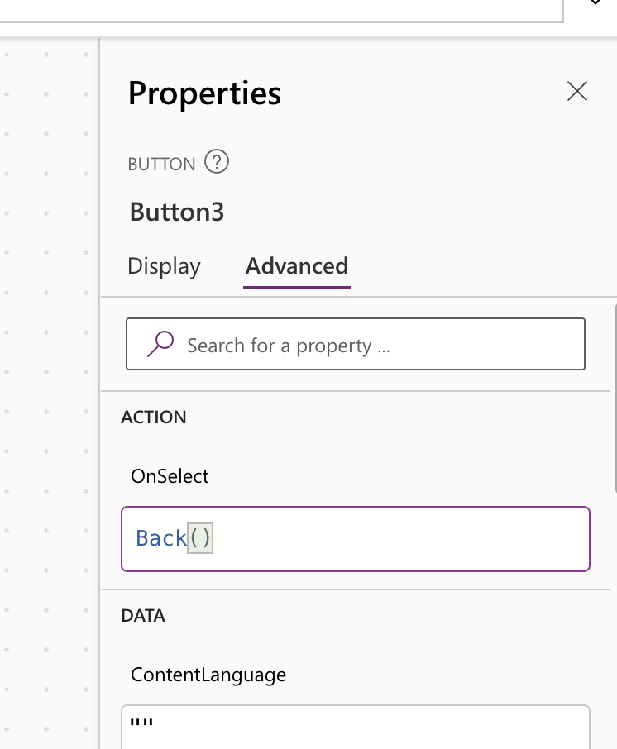

- Repeat for My Team, Availability Details, Manager Dashboard, and Help.
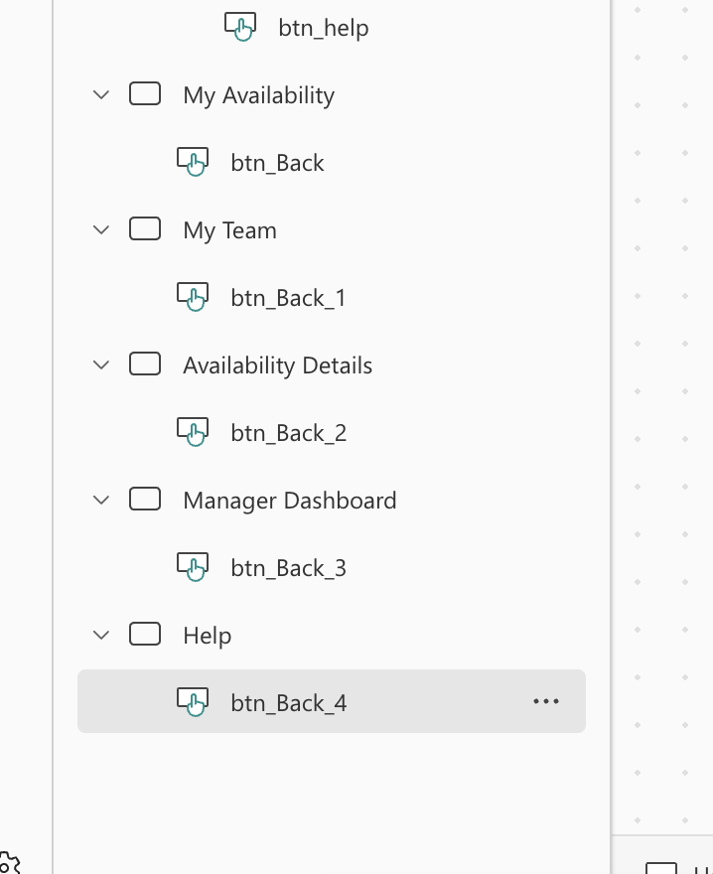

Part D — Apply a Consistent Theme
- Click the “Home” tab on the command bar (not the Home screen — the ribbon tab).
- Find the “Themes” gallery (a row of small color swatches) and click the one you like, or click the dropdown arrow next to it to see more options.
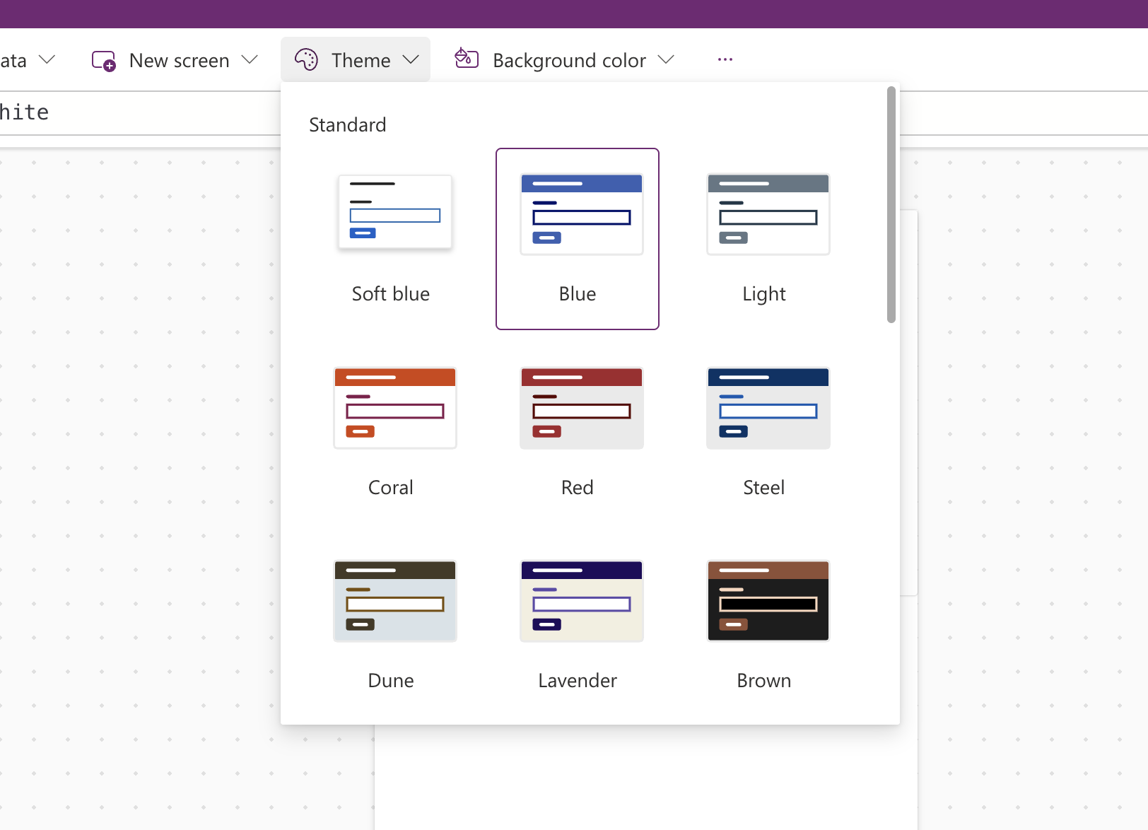
- Confirm the change by looking at the canvas —
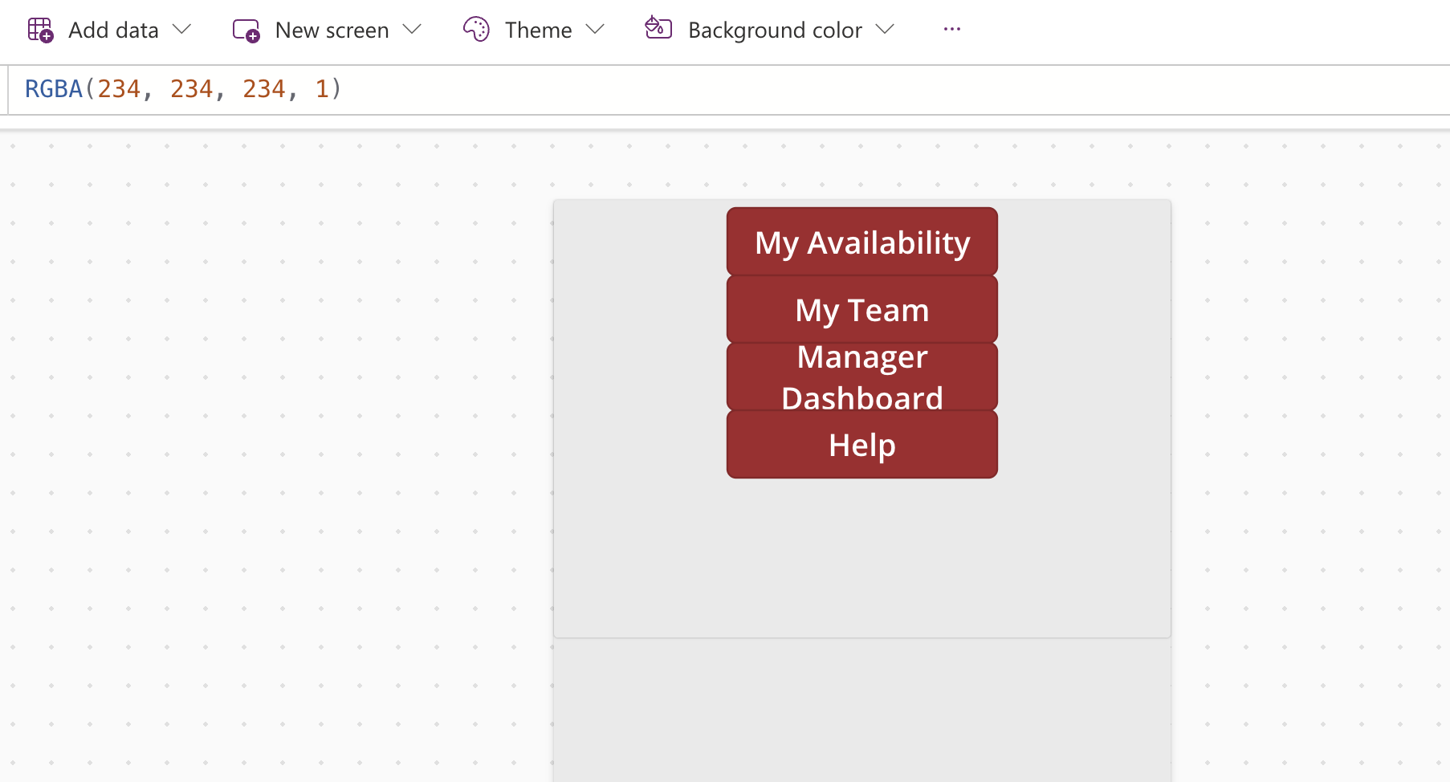
- background and default control colors across your screens should update to match.
💡 TIP
Applying a theme changes the default colors new controls will use, but it will not retroactively repaint controls you already customized by hand. Apply the theme before you spend a lot of time on colors, or expect to touch up a few controls afterward.

Part E — Preview and Test Navigation
- Click the Play button (▶) in the top-right corner of the command bar, or press F5.
- Your app now runs as an end user would see it. Tap each navigation button on the Home screen and confirm it takes you to the matching screen.
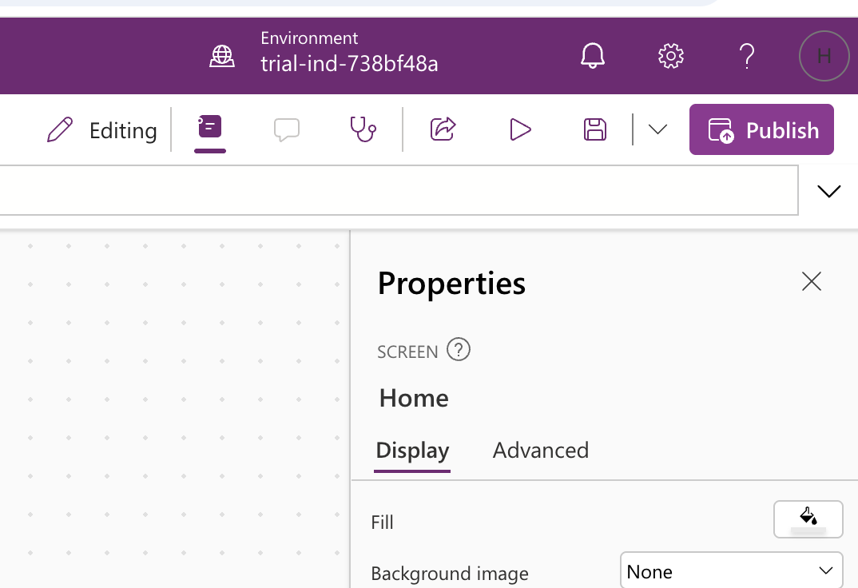
- On each other screen, tap “Back” and confirm it returns you to the previous screen.
- Exit preview mode by pressing Esc, or by clicking the “X” in the top-right corner of the preview window.
- Save your app again (Ctrl+S) once you've confirmed navigation works.
⚠ IMPORTANT
If a button does nothing when tapped, re-select it and check its OnSelect formula in the formula bar for typos — the most common mistake is a misspelled screen name inside Navigate().

Lab 01 Complete — Checkpoint
✅ CHECKPOINT
You should now have a saved app named “My Team Availability” with six named screens (Home, My Availability, My Team, Availability Details, Manager Dashboard, Help), a navigation menu on the Home screen, Back buttons on the other screens, a theme applied, and working navigation confirmed in Preview mode. In Lab 02 you will connect this app to the WorkforceAvailability data source you created in Lab 00.

Self-check questions
- What formula moves the user to a specific screen, and what formula returns them to the previous one?
- Where in Power Apps Studio do you rename a screen?
- Which pane shows the Text, Color, and OnSelect properties of a selected control?

Next: Lab 02 — Connect the Workforce Availability Data

